CHAPTER 1
INTRODUCTION

Introduction
The Student Complaint Management System (SCMS) is a web-based application developed to provide an efficient, organized, and transparent platform for managing complaints raised by students in an educational institution. In a college environment, students may face various issues related to academics, examinations, departments, hostels, transportation, infrastructure, laboratories, faculty, library facilities, and other campus services. Traditionally, these complaints may be submitted through paper forms, direct communication, emails, or other manual methods. Such approaches can make complaint management slow, difficult to track, and less transparent. The proposed Student Complaint Management System aims to digitize and simplify the complete complaint-handling process.
Through this system, students can submit their complaints online without having to physically visit different offices or departments. Once a complaint is submitted, it can be stored in a centralized database and made available to authorized administrators or staff members for further processing. The concerned staff can examine the complaint, take appropriate action, update its status, and provide resolution details. One of the important features of the system is complaint status tracking. After submitting a complaint, students can monitor its progress through different stages such as Submitted, Assigned, In Progress, Resolved, and Closed. This provides students with better visibility into the complaint-resolution process and reduces the need to repeatedly contact the administration for updates. The system also provides an administrative dashboard through which administrators can manage and monitor complaints efficiently.
  - Scope of the Project
The Student Complaint Management System (SCMS) is designed to provide a centralized digital platform for students to submit and track complaints related to academic, infrastructure, hostel, transportation, faculty, and other college-related issues. The system allows students to register complaints online, attach relevant information, and monitor the status of their complaints without visiting different departments physically.

Future Scope
- Email/SMS notifications for complaint status updates.
- AI-based complaint classification and priority detection.
- Sentiment analysis to identify serious or urgent complaints.
- Mobile application for Android/iOS.
- Dashboard with complaint statistics and analytics.
- Anonymous complaint submission where appropriate.
- Integration with college ERP systems.
- Automatic assignment of complaints to concerned departments.

CHAPTER 2

METHODOLOGY

2.1 Objective

The main objective of the Student Complaint Management System is to

develop a centralized digital platform for managing student complaints

efficiently.
- To provide an online complaint submission system where students can easily register their complaints.
- To reduce manual paperwork involved in traditional complaint management.
- To provide complaint tracking, allowing students to monitor the current status of their complaints.
- To enable administrators and staff to manage complaints from a centralized dashboard.
- To categorize complaints based on departments, complaint types, or priority.
- To improve communication between students, staff, and administrators.
- To maintain complaint records digitally for future reference and analysis.
- To improve transparency and accountability by maintaining complaint status and resolution information.
- To reduce the time required to process complaints and ensure that complaints are handled systematically.
- To provide a user-friendly and responsive web application that can be accessed through different devices.

2.2 Problem Statement
In many educational institutions, student complaints related to academics, infrastructure, hostel facilities, transportation, examinations, departments, and other campus services are handled through manual or unorganized methods such as paper forms, direct communication, or emails. These methods can lead to delays, difficulty in tracking complaints, loss of records, lack of transparency, and poor communication between students and administrators. Administrators, meanwhile, may struggle to manage and prioritize a large number of complaints efficiently. Therefore, there is a need for a centralized and user-friendly Student Complaint Management System that allows students to submit complaints online, enables administrators and staff to manage and resolve them systematically, and provides students with transparent complaint status tracking from submission to resolution.

2.3 Project Description
The Student Complaint Management System is a web-based application developed using the MERN Stack, consisting of MongoDB, Express.js, React.js, and Node.js. The main objective of the system is to digitize and simplify the process of submitting, managing, tracking, and resolving student complaints within an educational institution.
The Student Complaint Management System (SCMS) is a role-based web application with three types of users: Student, Staff, and Admin. Each user type has its own set of features and responsibilities, as described below.
2.3.1 Student Module
• Register as a student and log in securely using email and password.
• Submit complaints by providing the complaint title, description, category, and concerned department.
• Track the status of complaints such as Pending, In Progress, and Resolved.
• View responses and resolution details provided by the concerned staff or department.
2.3.2 Staff Module
• Log in securely and access complaints assigned to their respective department.
• View complete details of complaints submitted by students.
• Review and process complaints based on their category and priority.
• Update the complaint status such as Pending, In Progress, and Resolved.
• Add remarks or resolution details for complaints.
• View previously handled and resolved complaints.
2.3.3 Admin Module
Stats: View total students, staff members, departments, complaints, pending complaints, resolved complaints, and other system statistics.
Students: View registered student details and manage student accounts.
Staff: View staff details, assign staff members to departments, and manage their account status.
Complaints: View and monitor all complaints submitted by students, assign complaints to the concerned staff or department, and track their status.
Departments: Add, update, and manage departments involved in complaint handling.
Users: View all registered users along with their roles and account status, and activate or deactivate accounts.
Reports: Monitor complaint statistics based on department, category, status, and date to evaluate the overall complaint management process.

CHAPTER 3

RESULTS AND DISCUSSION

Screenshots:

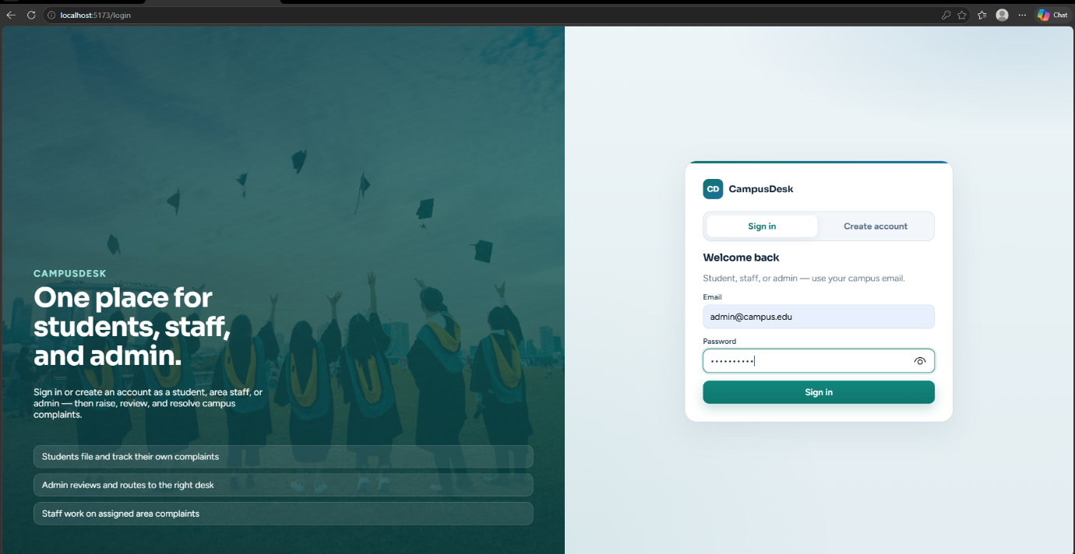

Figure 3.1 : The Login Page

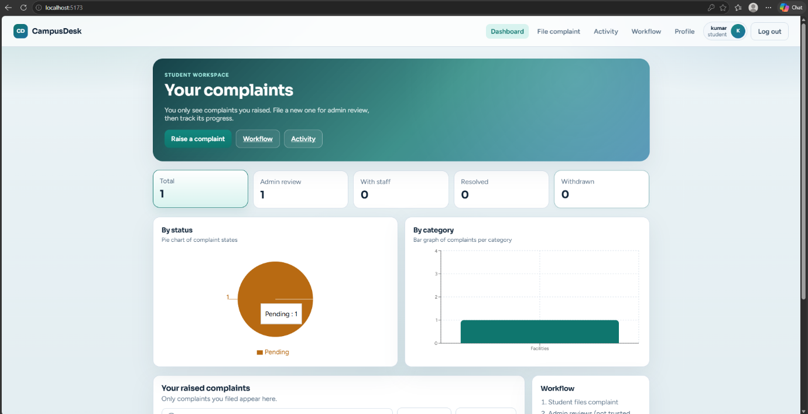

Figure 3.2 : Student’s Dashboard To View Complaints

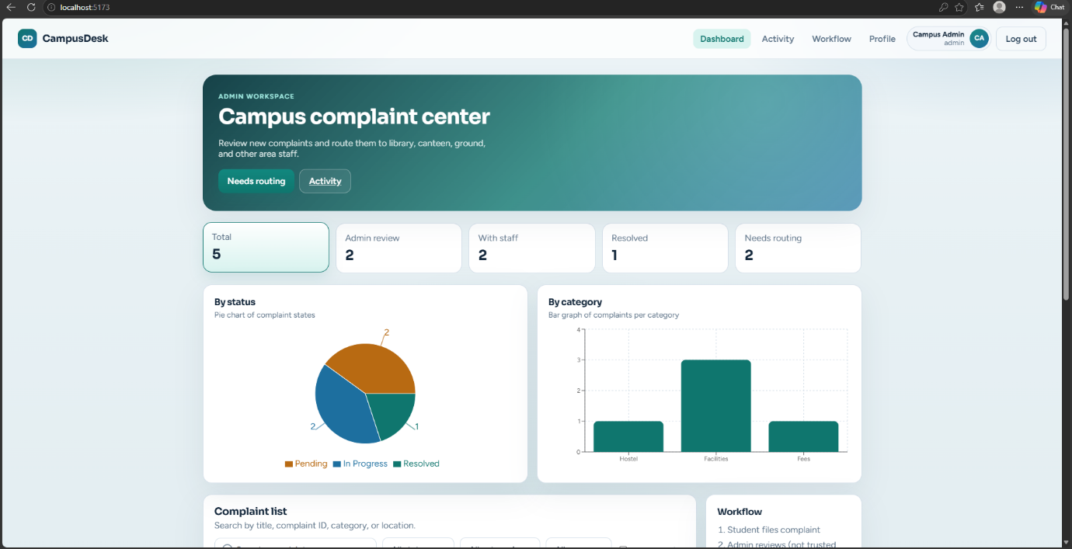

Figure 3.3 : Admin Dashboard Who Have The Overall Access of Complaints

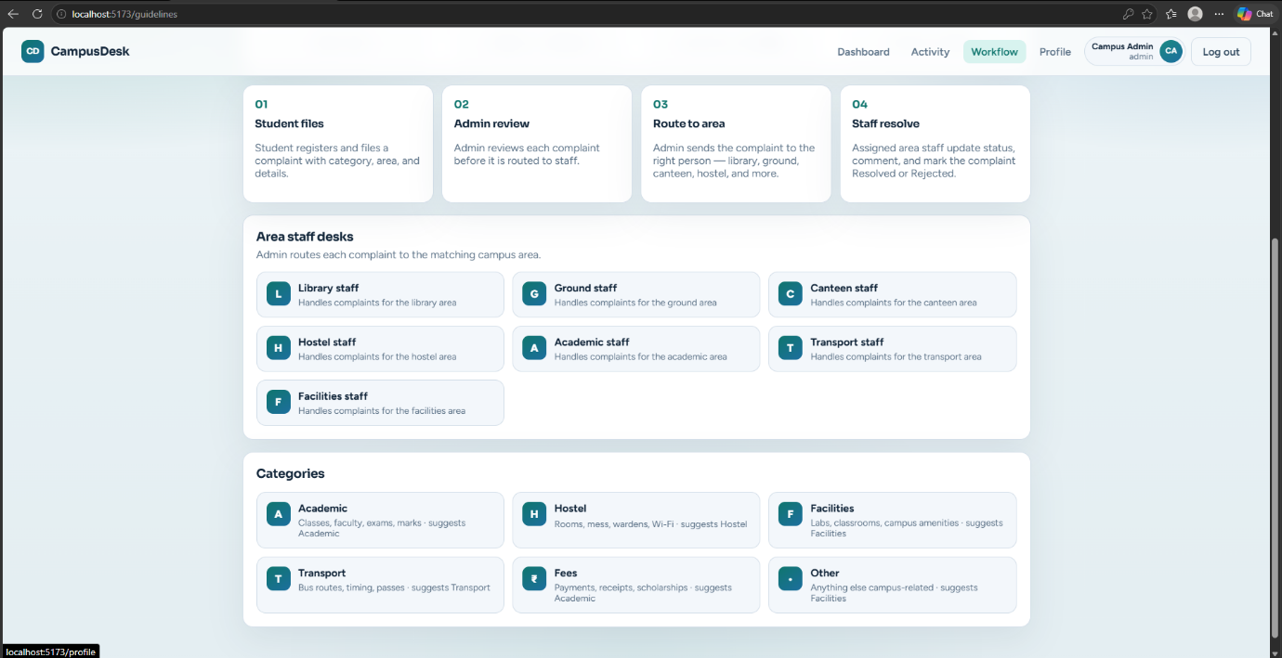

Figure 3.4 : WorkFlow Diagram To View The Complaint Details

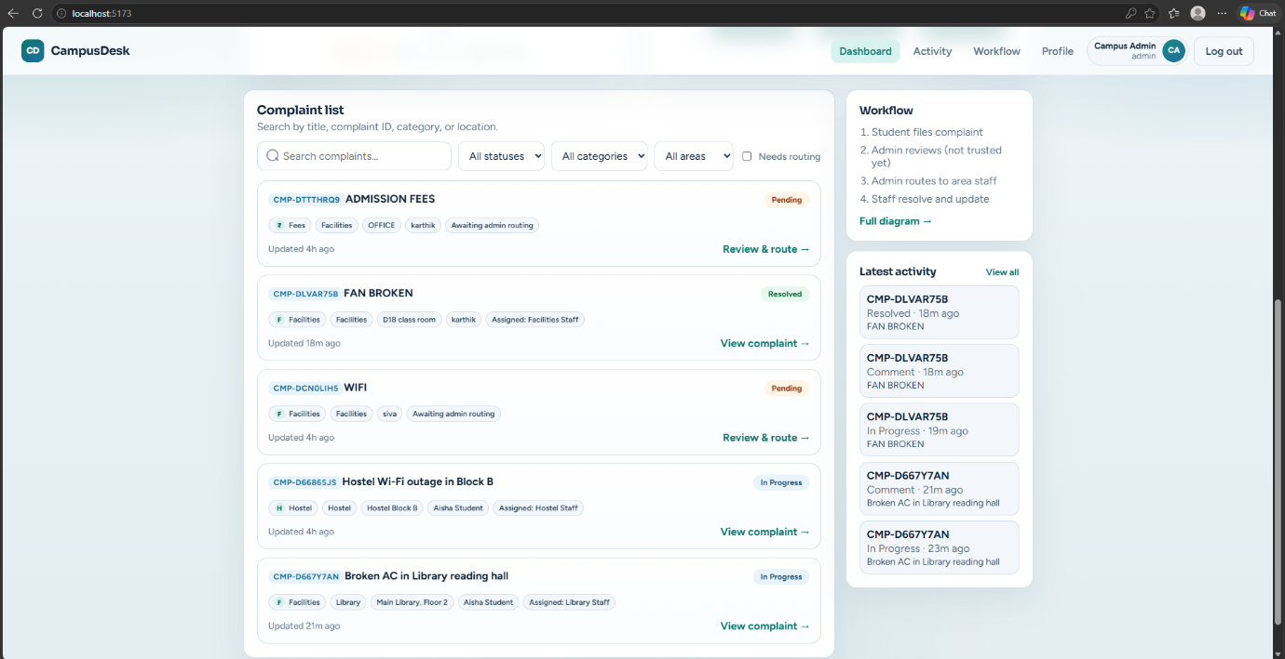

Figure 3.5 : Overall Complaints Arised By The Students

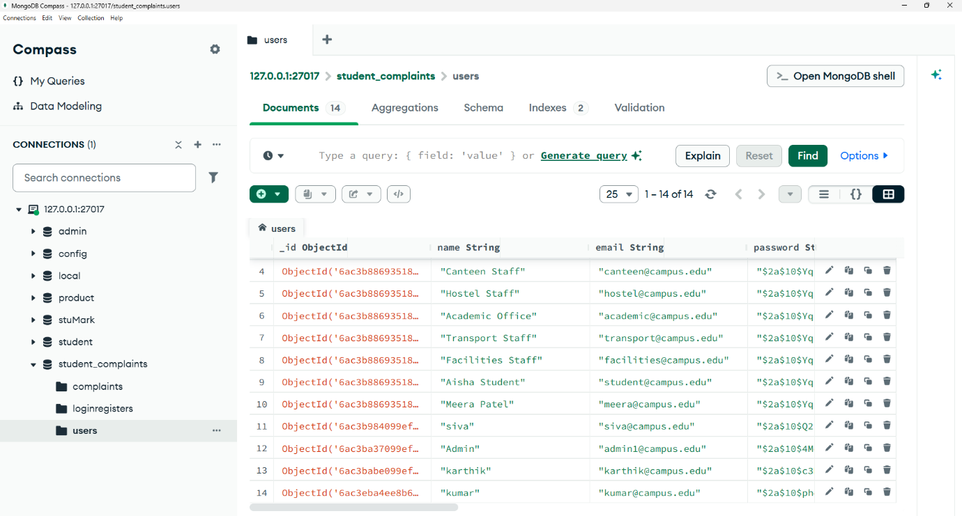

Figure 3.6 : MongoDB Where All Users Detailed Will Be Stored

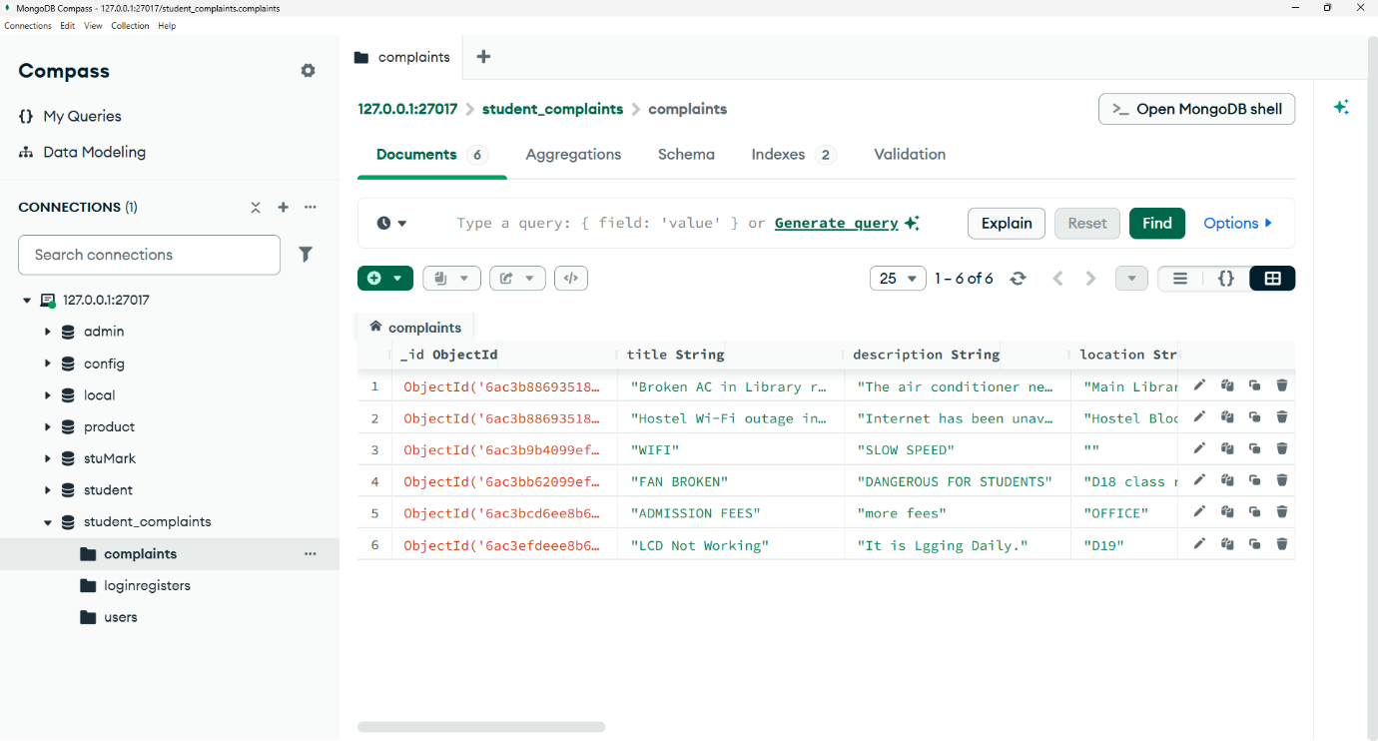

Figure 3.7 : MongoDB Collection Where All The Details Of Complaints Are Stored

Github Link:

https://github.com/Siva-ux-sketch/Student-Complaint-Management-System

CHAPTER 4

CONCLUSION
The Student Complaint Management System provides an effective digital solution for managing student complaints in educational institutions. The system replaces traditional manual complaint handling with a centralized web-based platform.
By using the MERN stack, the application provides a modern, scalable, and interactive environment for students, staff, and administrators. Students can submit and track complaints, while administrators and staff can efficiently manage and resolve them.
The system improves transparency, accountability, communication, and efficiency in the complaint resolution process. It also maintains complaint records digitally, making it easier to analyze previous complaints and identify recurring issues.
Overall, the Student Complaint Management System helps educational institutions provide a more organized and responsive complaint-resolution process. In the future, the system can be enhanced with features such as email/SMS notifications, AI-based complaint categorization, priority prediction, analytics dashboards, feedback and rating systems, and mobile application support.

REFERENCES

- MongoDB Documentation – Used as a reference for database creation, collections, CRUD operations, and data management.
MongoDB Documentation
- React.js Documentation – Used for developing the frontend user interface using reusable components and React concepts.
React Documentation
- Node.js Documentation – Used as a reference for backend development and server-side JavaScript execution.
Node.js Documentation
- Express.js Documentation – Used for developing REST APIs, routing, middleware, and backend services.
Express.js Documentation
- Mongoose Documentation – Used for MongoDB schema design, data validation, models, and database interaction with Node.js.
Mongoose Documentation
- MDN Web Docs – Used as a reference for HTML, CSS, JavaScript, HTTP, forms, and other web development concepts.
MDN Web Docs
- JSON Web Tokens (JWT) – Used as a reference for implementing secure authentication and authorization in web applications.
JWT Introduction
- Axios Documentation – Used as a reference for making HTTP requests between the React frontend and Node.js/Express backend.
Axios Documentation
- React Router Documentation – Used for implementing navigation and routing between different pages and modules of the application.
React Router Documentation
- NPM Documentation – Used for managing project dependencies, packages, scripts, and Node.js-based project configuration.
npm Documentation

